Project plan: ESD Group 19

**Members**

Harry Marsh

Kamil Lukomski

Adam Gilley

Josef Anstey

Finley Horsley

**Sprint 1: Creation of project and setup of planning**

Planning

 During discussions each task that is required to be looked into and developed is shown in the Task Delivery form.docx

Each individual will work on a field of the project. It would be wise to provide necessary insights to give confirmation if the objective for a task is met.

There can be a time management scheme used to give out how much time a person will spend before moving onto the next objective. It will be wise on some occasions where some areas will need more work depending on how important that area is and what the benefits are.

There will need to be necessary reviews on everything done before officially submitting it onto the blackboard.

Scheduling

 Weekly meeting set up for 4PM Every Thursday.

The purpose of these meetings is to update each other on the progress made for each of our assigned tasks visible in the Task Delivery form.docx.

Our medium of communication is a communication application called discord. We decided on this as we are all familiar with the software and it provides useful features such as file share and screen share.

**Demonstration**

Below is the demonstration of login system as well as registration

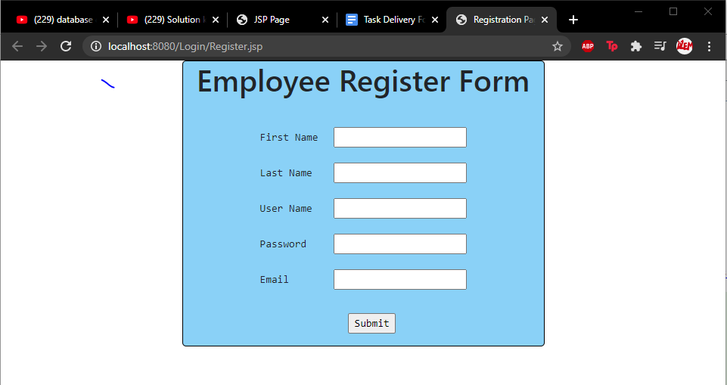

[Figure 1: Created a registration form so new users can register to the software. This data is then added to the users table in the database.]

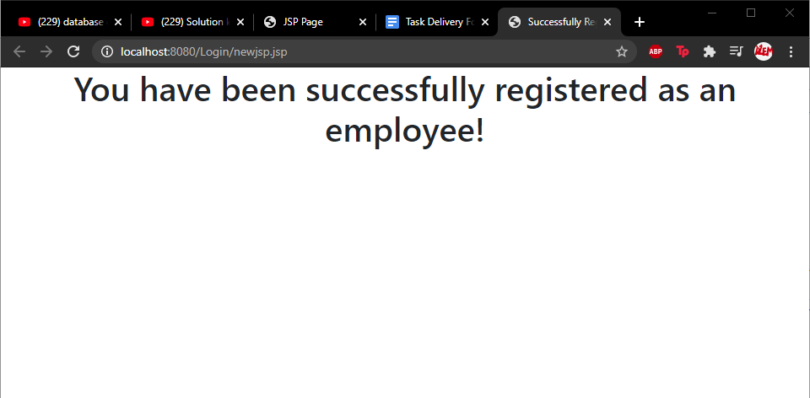

[Figure 2: Page displays that the user has successfully registered and the data is added to the database.]

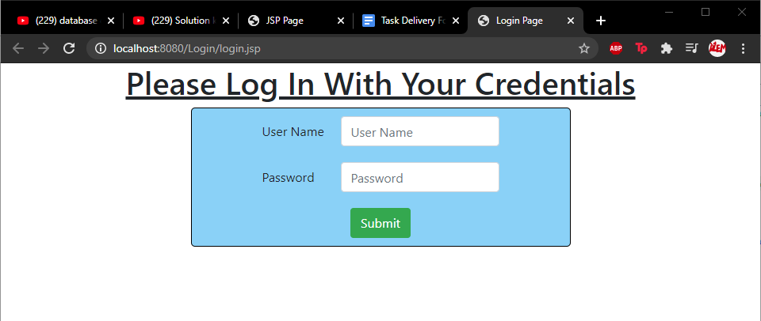

[Figure 3: The login screen for users to gain access to the system which is going to be developed in sprint 2.]